**Li-Fe-PO4 Tear Down-Documentation:**

Description:

On March 15th, 2017, a teardown of one of the Li-Fe battery cell blocks was conducted for both educational and troubleshooting purposes. This document is created such that anyone whom the internal structuring of such batteries interests as well as a reference point as to what a functioning charging controller may look like.

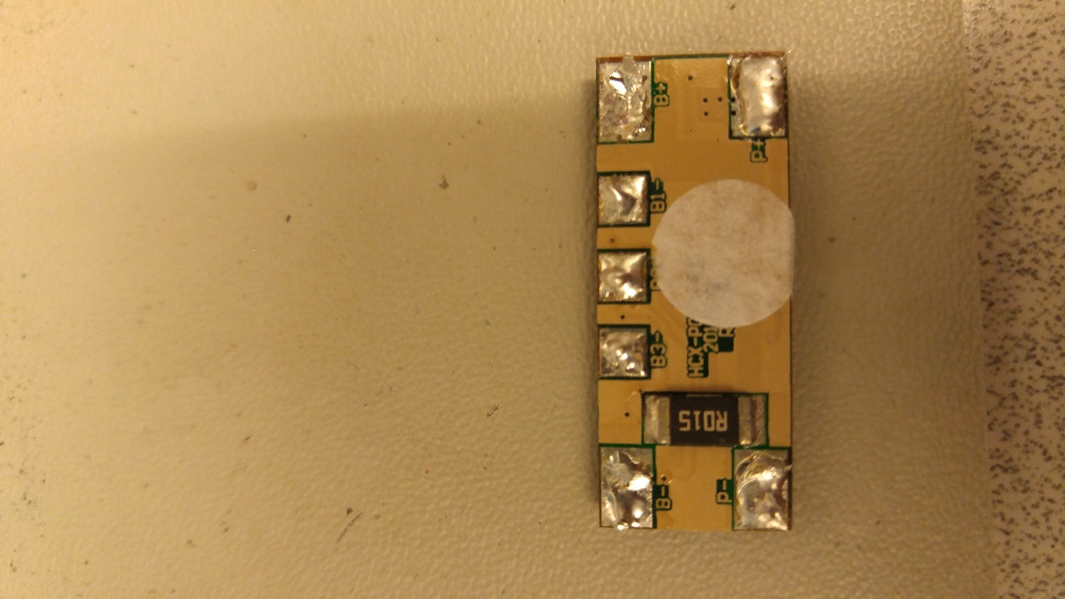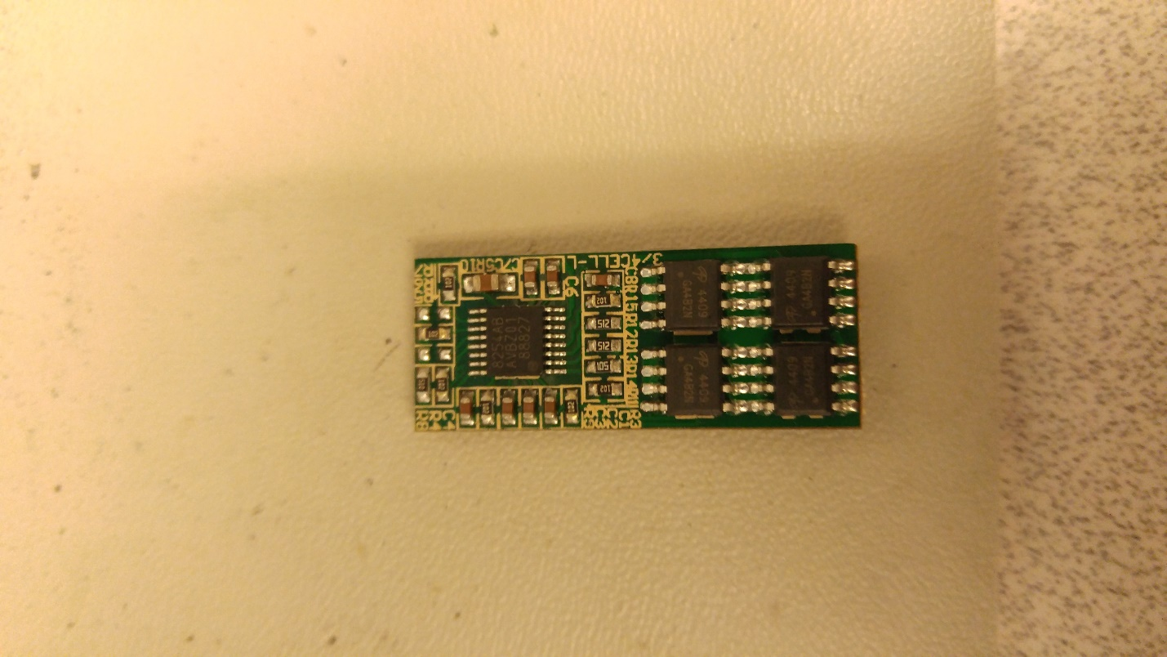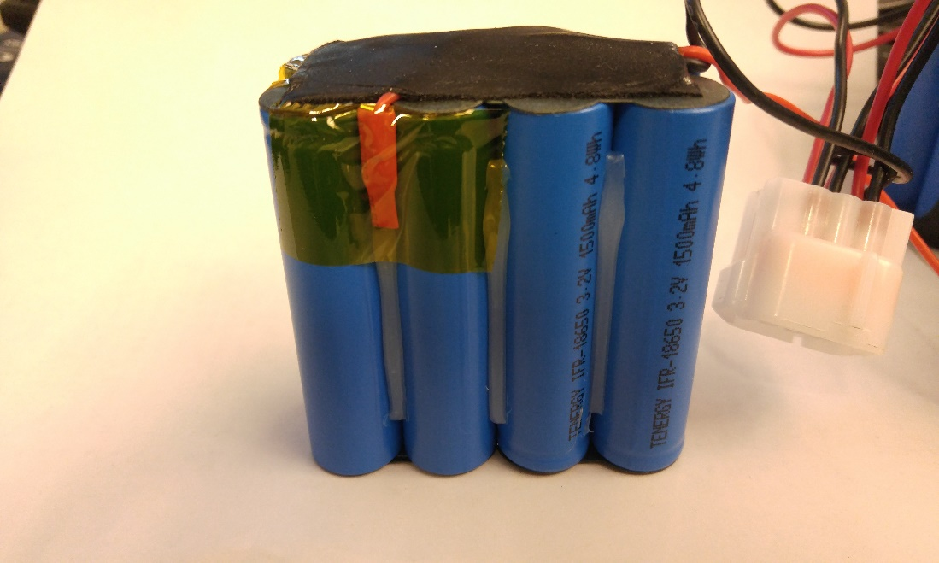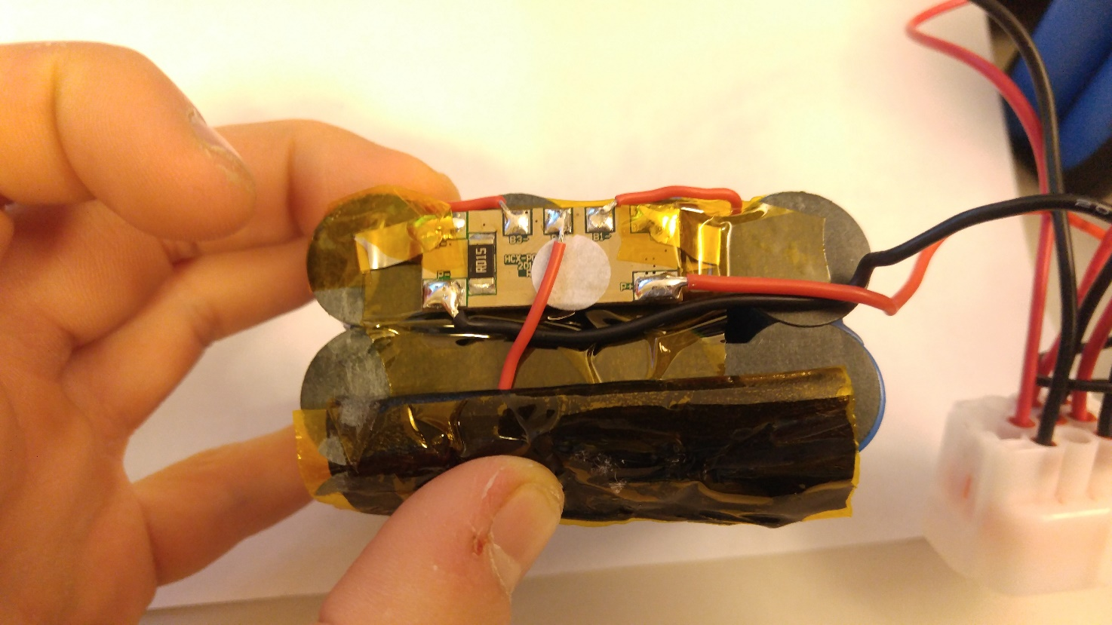

As seen in the illustrations above, the Cell block consists of eight individual cells, each with a rating of 3.2 Volts meaning that they are connected parallel in pairs which are then in series with each other. Further analysis into which cell is faulty was not conducted as there was no physical evidence that the charging controller was faulty. Based on this assessment and further performance test it was decided that one of the cells cuts out after a certain period of time under load or at a certain operation temperature.

For any further information about the batteries refer to manufacturer dependent Datasheet.  
Single cell type: LiFePo4 18650 3.2V 1500mAh 4.8Wh